Lab Report

Your Information
Your Name: Joshua Zimmerman-Gibson
Assignment Title: Analyzing and Visualizing Streaming Data

Screenshots
Created Kinesis Firehose Stream
Created an Amazon Kinesis Firehose stream to prepare for use with a Kinesis Agent.
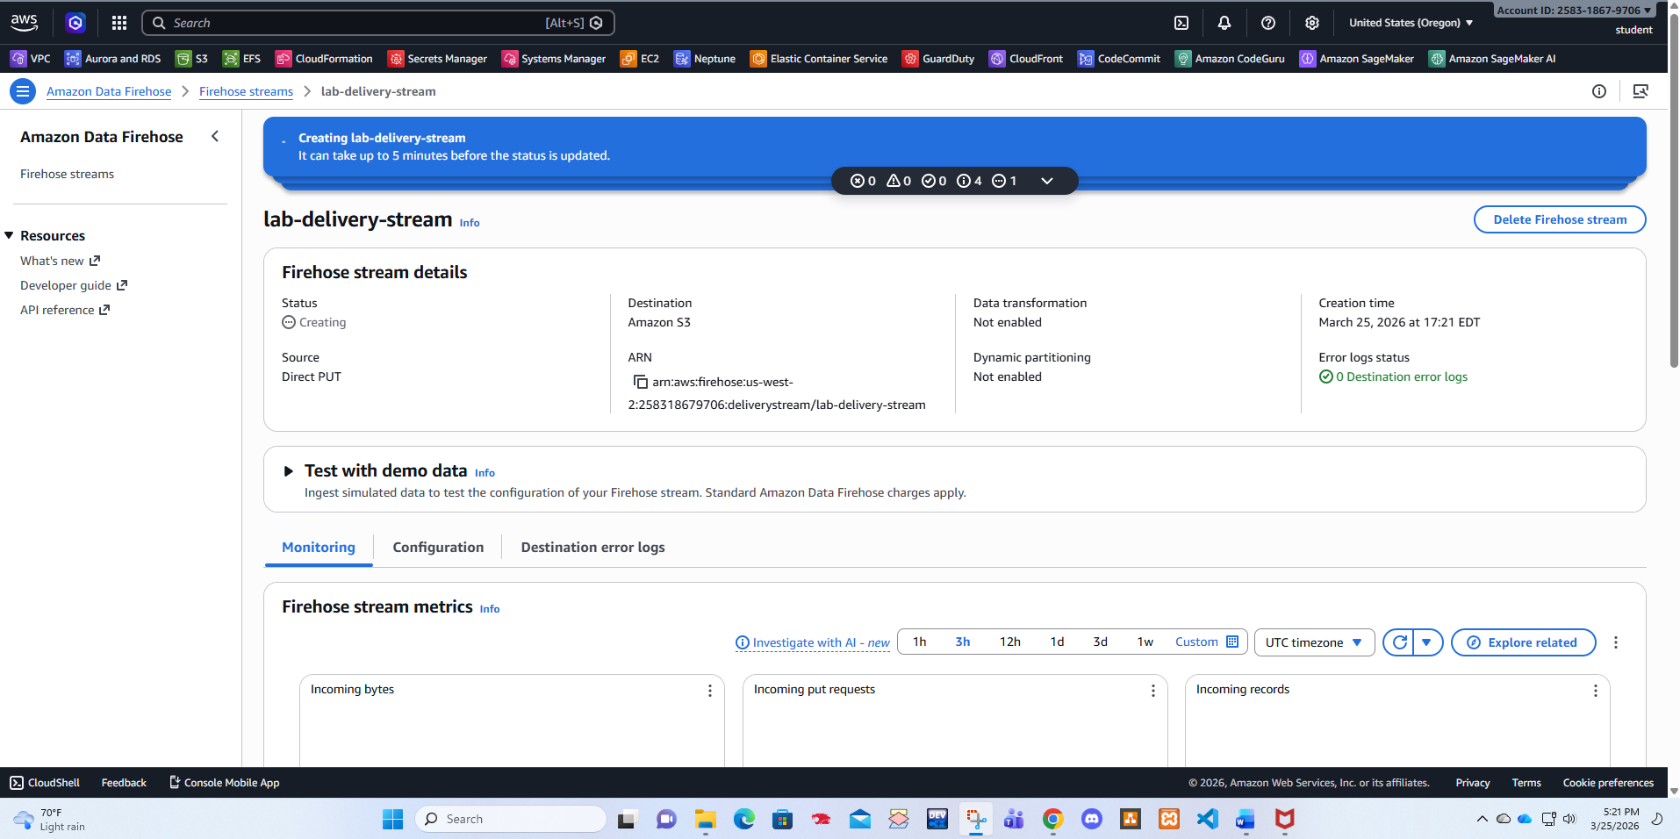
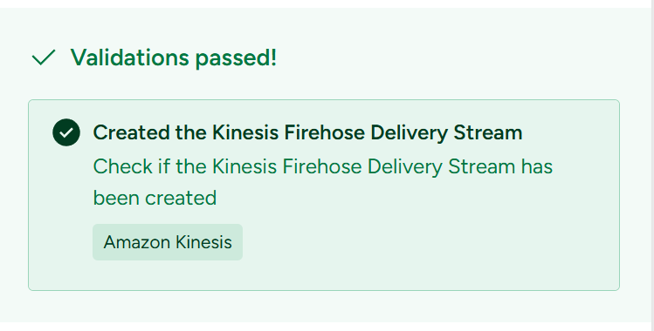
Install and Figure Kinesis Agent
Installed and configured an Amazon Kinesis Agent and generated sample log data to process with the agent.
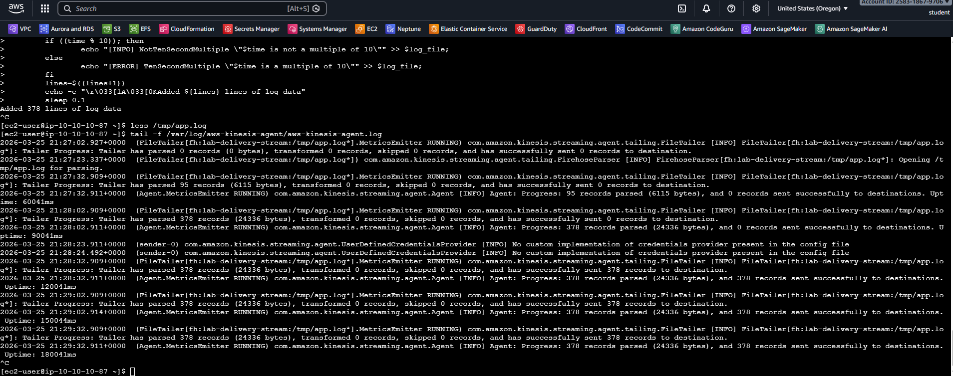
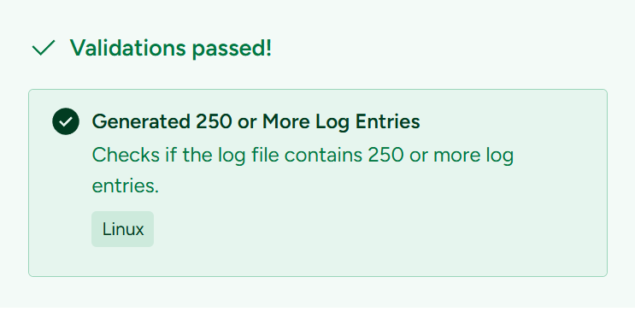
Queried Log Data
Used Amazon Athena to query the sample log data.
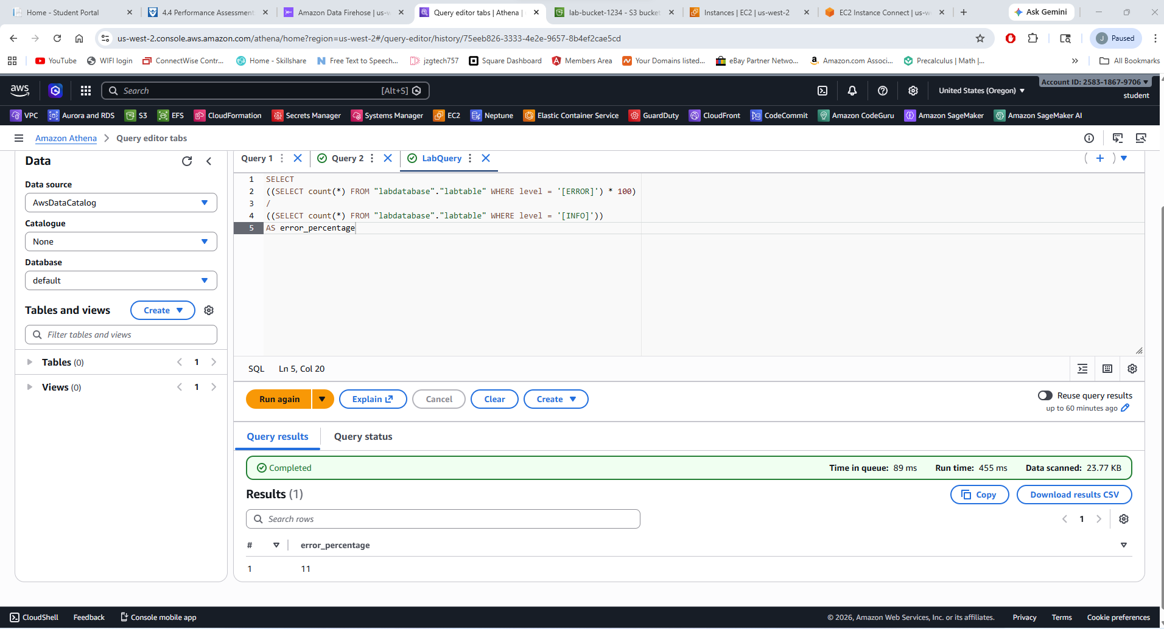
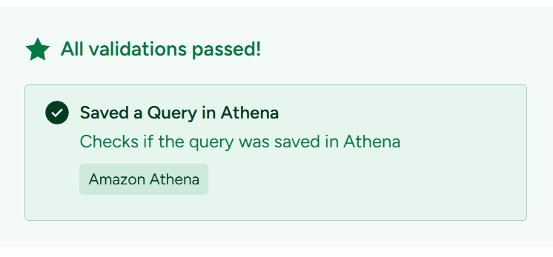
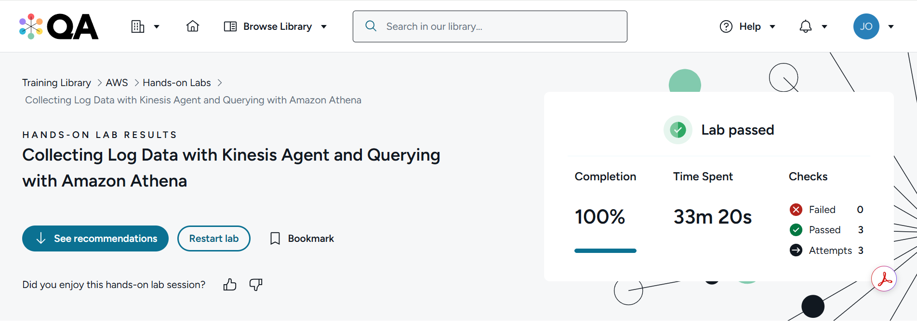

Questions
- What is streaming data and how is it different from other forms of data?
Streaming data is data that comes in continuously and in real time. Instead of getting all the data at once, it arrives little by little as it’s being created. Examples include live website click logs, app activity, or sensor data.
This is different from other types of data, like files or databases, where data is stored first and analyzed later. With streaming data, you often want to process or analyze it right away while it’s still coming in.
- What is an Amazon Kinesis Agent and what can it do?
An Amazon Kinesis Agent is a small program you install on a server or computer. Its job is to collect log files or data and send them automatically to Amazon Kinesis services, like Kinesis Firehose.
The agent makes things easier because it handles reading the data, sending it, and retrying if something goes wrong. This helps move streaming data to AWS without writing a lot of custom code.

- What steps can you take to evaluate and address the performance metrics of an Amazon Athena query?

First, we can check how long the query takes to run and how much data it scans. Athena shows this information after each query runs.
To improve performance, you can:
- Reduce the amount of data scanned by using partitions and selecting only the columns we need
- Use efficient file formats like Parquet or ORC instead of plain text
- Clean up SQL queries so they are simpler and more direct
Doing these steps helps make queries faster and cheaper.

